10.93: The train’s speed relative to the earth is 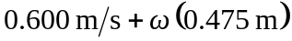, so the total angular momentum is

from which 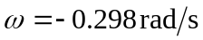,with the minus sign indicating that the turntable moves clockwise, as expected.

